Current Activities & Acquisitions
Since the last report we have been concentrating on two activities. Firstly we have made good progress in creating information cards for those displays where they were missing. Each card can take quite a while to produce if we don’t already have the product information. After trawling our own documentation then the web, we can end up with little information or huge amounts. Either way, we update the online database first, and then create a summary on the card. In addition if there’s enough information online we create a QR code pointing at the web page.

Secondly, we have made considerable progress cataloguing the reserve collection. There’s a long way to go, and we’ve found some artefacts we didn’t know we had.

Two Hursley departments have been having a major clear out and invited us to take what we wanted. One area yielded a lot of miscellaneous hardware, software and documentation. The other, the Storage Systems Development group, yielded a quantity of SSA disk adapter cards and hard disks. We also found a prototype for the Redwing hard disk, which had two actuators, whereas the finished disk only used one.
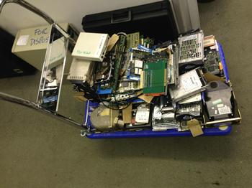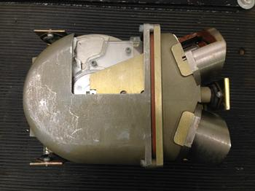
A Trolley Load of Storage “Osprey” – Redwing prototype

An IBM retiree has donated a set of framed IBM advertisements from the 1950s, extolling the lightning fast computing power of electro-mechanical machines and valve-powered computers. These now hang behind the Royal Army Pay Corps 705 console.
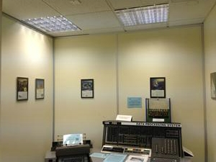

New Display Items
No significant changes, we have just done some moving around of artefacts in display cabinets to provide a better timeline.

Other
After the loss of an artefact out on loan that we reported earlier in the year, we have implemented more regular checks on loans and the people responsible. Unfortunately this revealed that our 011 electric hand punch, on loan to us from the Army, and loaned out to a Hursley department, has disappeared. The responsible manager had moved on, and we’ve not been able to find anyone who knows what happened. This was our only example of this punch, so our loans policy has been further revised to only lend items where we have at least two and preferably more.

